16.THREE ADDRESS CODE

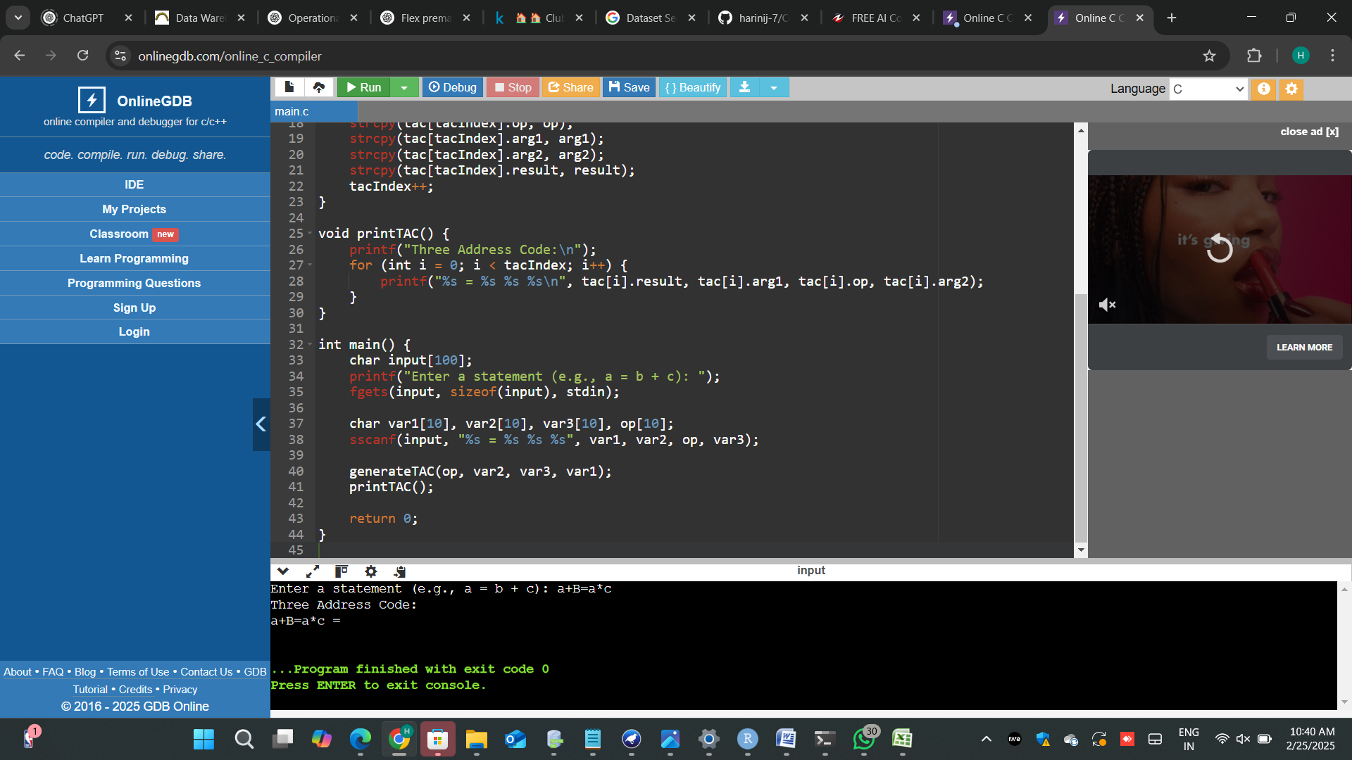

17. Write a C program for implementing a Lexical Analyzer to Scan and Count the number of characters, words, and lines in a file.

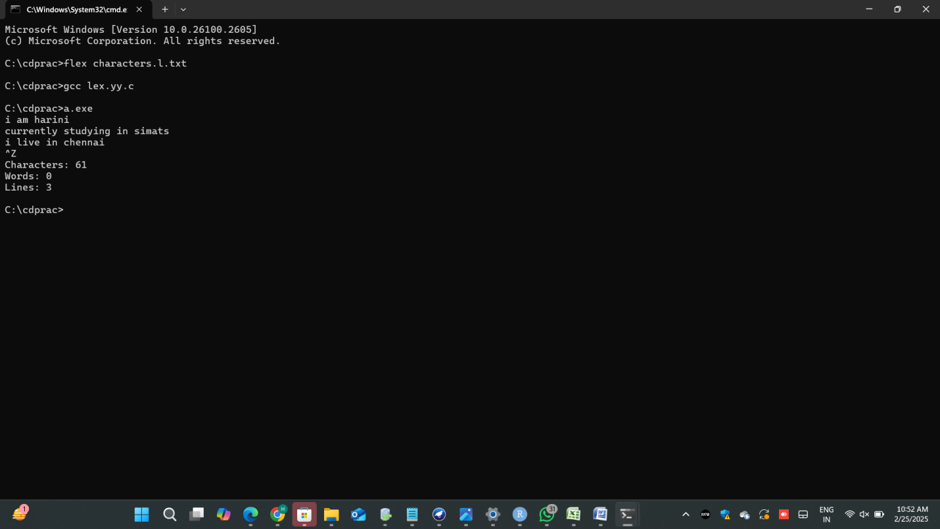

18. Write a C program to implement the back end of the compiler.

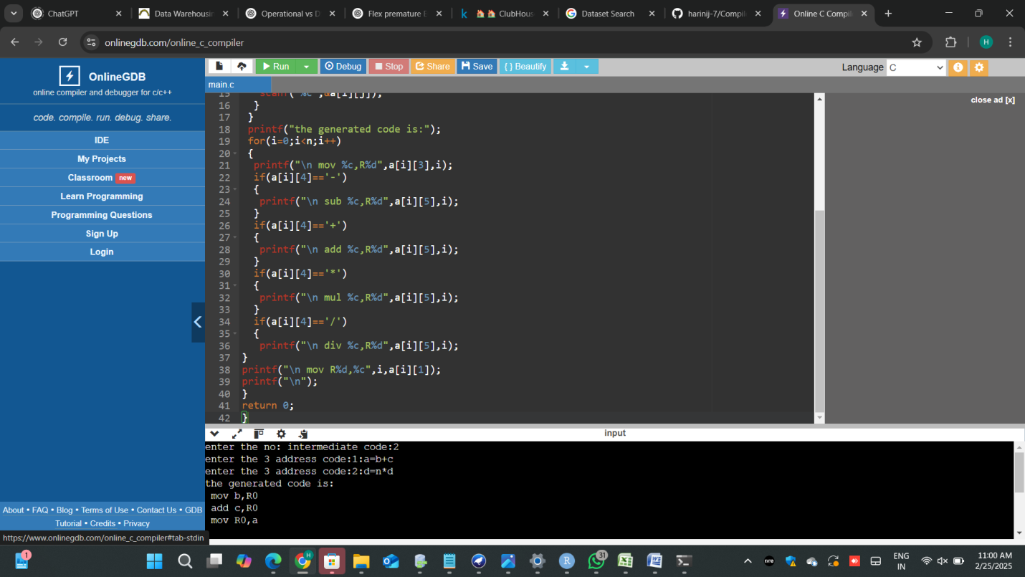

19. Write a C program to compute LEADING( ) – operator precedence parser for the given grammar

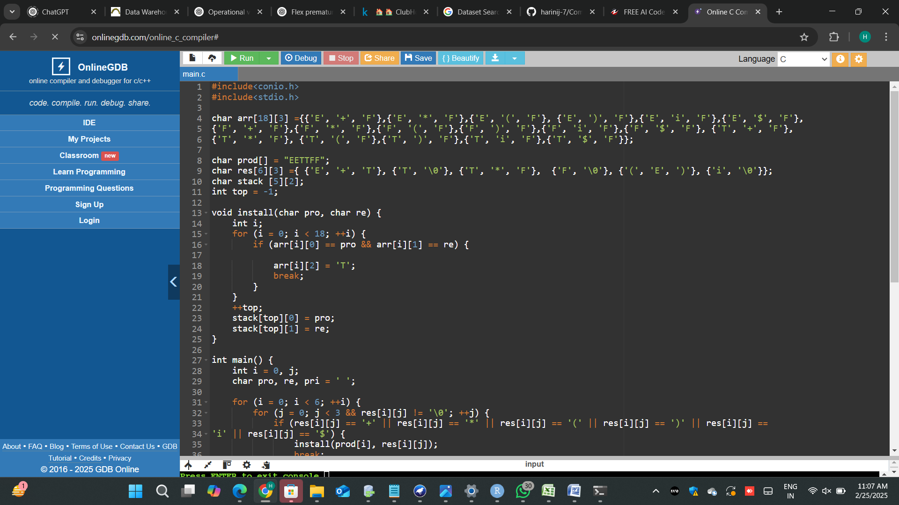

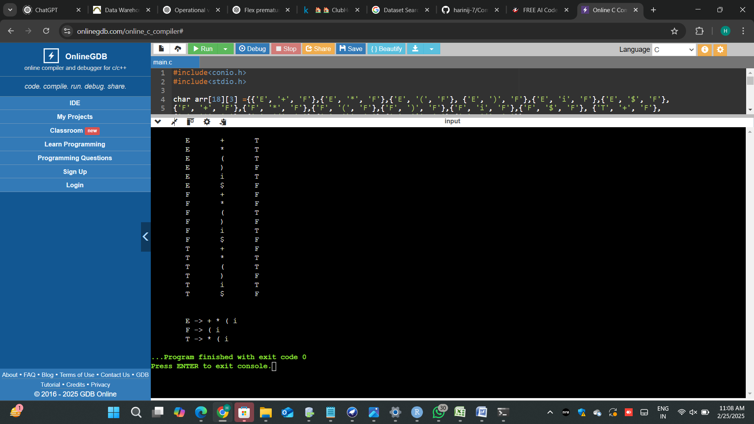

20. Write a C program to compute TRAILING( ) – operator precedence parser for the given grammar

